COMP 8082 - Project Management

Band Social Media Website

Software Development Plan

**Prepared by**

Jackee Ma (A00872688)

Zilong Wang (A01001507)

January 28, 2019

# Description

The purpose of Band Social Media website is to help musicians find bandmates, create bands, and build a bridge between the musician and the event organizer.

In our website, the musicians will be able to show their talent, market themselves, and get the opportunity to participate in various activities. They will also be able to find friends who also love music, invite bandmates, and create their own bands.

On the other hand, for the event organizers who want to invite some bands to participate in their activities, this website will also help them to find the most appropriate bands they want.

# Proposed Solution

In our website, there will be two types of users, musician and organizer. The musician will be able to create their bands with the other musicians, and the organizer will be able to post a page about an upcoming event with a location. Then there will be a section for bands to apply for a position at the event.

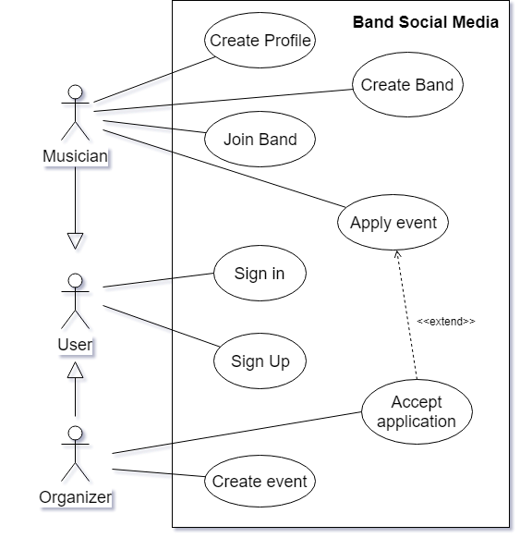

*Figure 1 Band Social Media Use Case*

The musician’s role in the system is to create a profile page to market themselves and there will be a function to allow musicians to look for fellow bandmates. For example, suppose a band needs a guitarist, a user must be able to search the website and a list of guitarists will show up. After adding a few other musicians to their band, a musician will be able to create a page to market themselves e.g. what type of music genre they play or available hours.

The organizer’s role in the system is to create an event to invite the bands. They will be able to describe the detail of the event such as schedule, location, and requirements. When they receive the band's application for the event, they can check the band's page and the introduction of each musician, and decide whether to accept it.

# Proposed Technology

We will be able to create a dynamic website with a database, a web server with a RESTful API system, and a set of web pages to pull and display all the data.

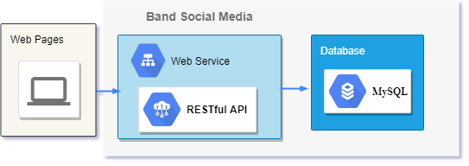

*Figure 2 Technology structure*

For the backend, this project will use MySQL for the data storage, Spring Framework build-in Tomcat for the web server. For the business system, we will use Spring Framework for creating a RESTful API system.

The website frontend will base on HTML5 and CSS3. We are still evaluating whether to use the front end framework like AngularJs or jQuery. The evaluation will be based on the ratio of efficiency gains and learning costs.

|  |  |
| --- | --- |
| Database | MySQL |
| Backend | Spring RESTful framework (Java) |
| Frontend | HTML5, Javascript, CSS, etc |
| Web Service | Tomcat (Spring build-in) |

*Table 1 Technology list*

For project management, we will use Gradle for library control and Github for code version control.

All the document will be shared on Google Drive, and our tasks will be managed on Trello. Our development teams will meet once a week in order to communicate with any problem and answer developers’ questions concerning the project. Finally, the developers will be filling out weekly documents in order to make sure everything is working out.

|  |  |
| --- | --- |
| Library control | Gradle |
| Code version control | Github.com |
| Document cloud | Google Drive |
| Tasks Management | Trello.com |
| MySQL Management | MySQL Workbench |

*Table 2 Management Tools*

# Project Goals

The main goal of this project is to deliver a new website for musicians and organizers to market themselves.

This project also has two internal goals

* For developers to practice how to use the MySQL database, which will focus on
  + Table design
  + Develop with databse
  + Using SQL to
    - Query and display data in web pages
    - Implement business logic by modifying data
* For managers to practice how to apply rapid development, which will focus on
  + Planning and schedule management
  + Decision-making
  + Risk management
  + Resource management
  + Quality assurance

In 7 weeks, we will help our developers practice the use of relational database and website development. Mainly different technology stacks and habits will be touched.

# Deliverables

The deliverables will include:

* Weekly documents
* A MySQL database server
* A RESTful API system
* A set of web pages

# Out of Scope

Due to limited time and resources, this project will only focus on implementing basic business functions and will not be published to the Internet at this stage. Therefore, although the following items are very important for a social media website, we will not pay attention to them in this project:

* Security
* Performance
* Availability
* Accessibility
* Stability
* UI Design
* UX Design
* Domain
* SEO
* Policy & Copyright

Weekly Schedule

Week 1:

* Exchange contact information
* Setting up all the technologies tools on all laptops/computer.
* Create a local database with a test table.
* Set up a simple RESTful API.

Week 2:

* Create an empty web page directory structure and have it show the title of the URL.
* Design and create tables related to the account.
* Implement login/register system include pages and API.

Week 3:

* Design and create tables related to the user and bands.
* Implement pages for musicians:
  + edit/display user profile
  + create/edit/display bands
* Implement feature: join bands

Week 4:

* Start Test
* Design and create tables related to the events.
* Implement pages for organizers:
  + create/edit/display upcoming events
* Implement feature: bands apply for events
* Implement features: Accept/Reject the application

Week 5:

* Implement home page: searching bands/events/musicians
* Test and Bug fixes

Week 6:

* Organizing all the technical documents and practice a project presentation.

Week 7:

* Handing in the project/present.

# Work Breakdown

We will be assigning a specific task on Trello and use an agile approach for the project. Project task are assigning/discussed at the beginning of the week and we’ll monitor progress later in the week.

For each page, it includes the implement of the frontend, the restful API, and database table design and SQL development.

|  |  |  |
| --- | --- | --- |
| Category | Page | Assigned to |
| User | Register page |  |
|  | Login page |  |
|  | Edit/display user profile (2 pages) |  |
| Bands | Create/edit/display bands (3 pages) |  |
|  | Join bands (in display band page) |  |
| Events | create/edit/display upcoming events (3 pages) |  |
|  | Bands apply for events (in display events page) |  |
|  | Accept/Reject the application |  |
| Home Page | Search and list bands/events/musicians |  |

*Table 3 Work Breakdown*

# Risk and Issues

Since all participants are students and the developers may lack technical experience, the following risks may arise:

* Schedule conflict, the hours that the students work on the project might be much less than full time worker for there are other courses.
* Learning new technologies might be a major obstacle to this project.
* Participation would only base on initiative.

In case things go wrong, the worst solution would be that let experienced member make up for the missing parts at the last.